**Computer Assignment 2**

**ME 543 Computational Fluid dynamics**

**Submitted by**

**Name: Rajiv Lochan Baruah**

**Roll No: 154103093**

**Table 1: Discretised Equations**

|  |  |
| --- | --- |
| FTCS |  |
| BTCS |  |
| ADI | X sweep:  Y sweep: |

**Table 2: Comparison of results**

|  |  |  |  |
| --- | --- | --- | --- |
|  |  | **Copper** | **Iron** |
| **FTCS** | Time till Convergence | 7530 | 5574 |
|  | CPU execution Time | 3 | 2 |
| **ADI** | Time till Convergence | 6761 | 5075 |
|  | CPU execution Time | 2 | 5 |
| **BTCS** | Time till Convergence | 6645 | 8108 |
|  | CPU execution Time | 164 | 87 |

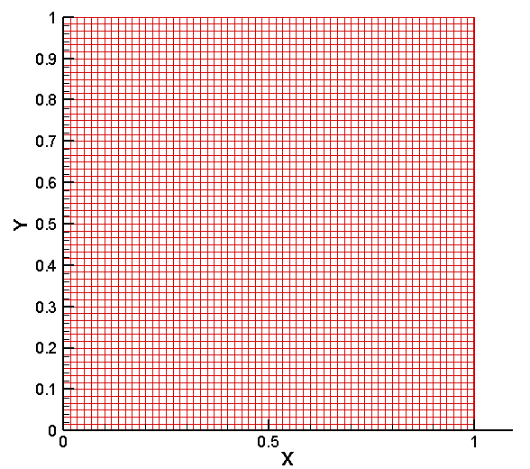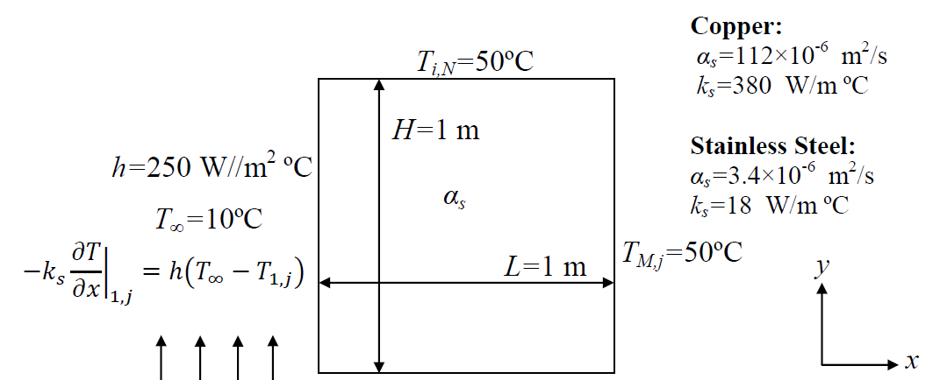

Fig: Discretised Domain with Problem Definition

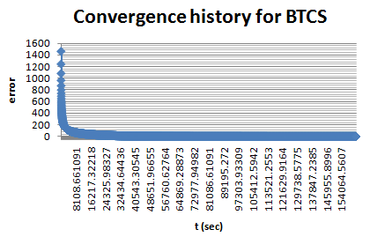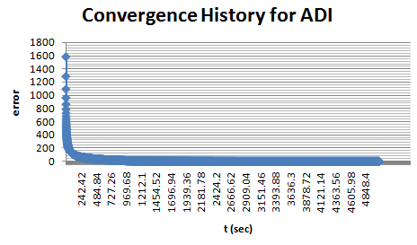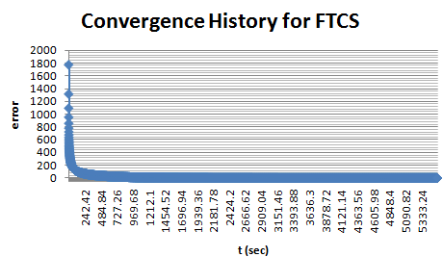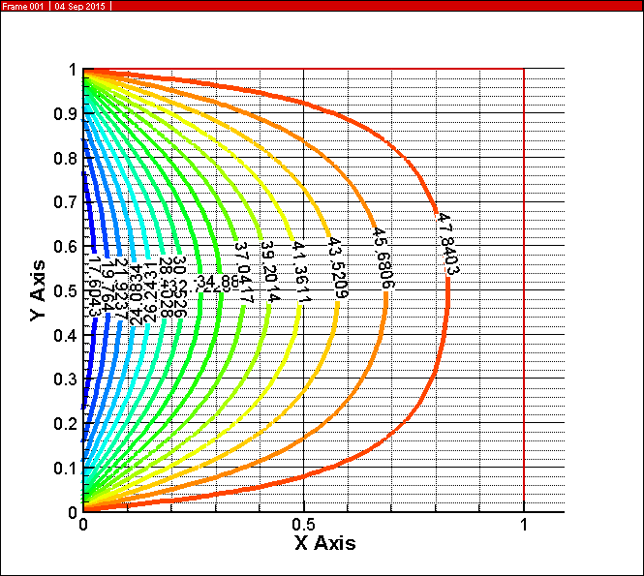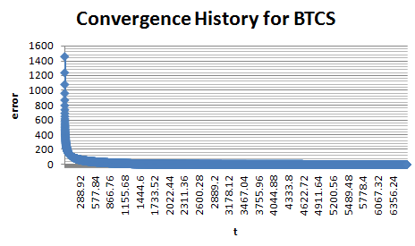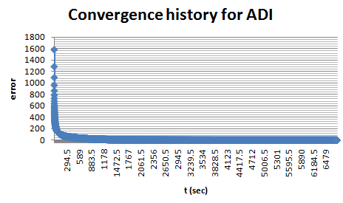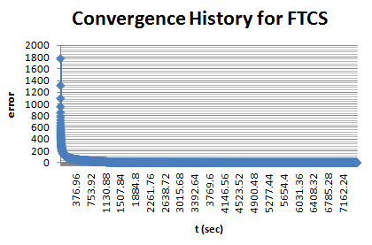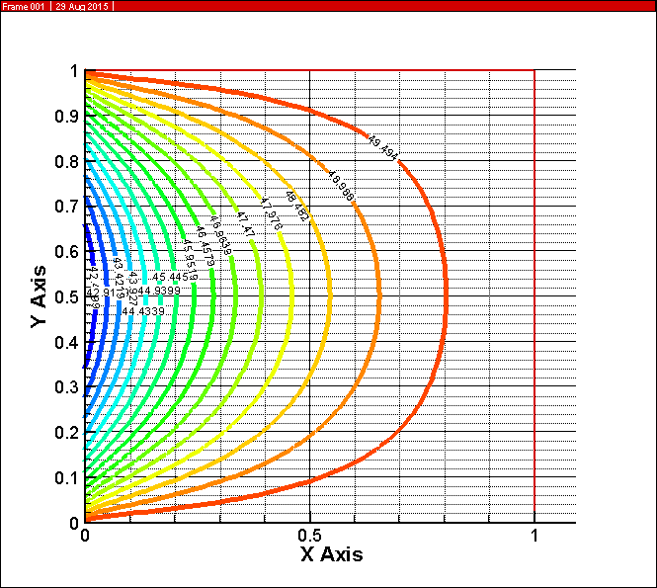

Fig: 2 Convergence histories for all the three methods for Copper

Fig: 4 Convergence histories for all the three methods for Iron

Fig: 2 Temperature Contour for Iron

Fig: Temperature Contour for Copper